 Methods Unit 3 Test 3, 2017

Name__________________

**Non-Calculator Section (No calculator or notes, formula sheet provided)**

**Time: 19 minutes Marks: 19 marks**

1. [2, 2 marks]

Determine if X in each of the following is a Discrete Random variable. Give a reason for your choice.

|  |  |  |  |  |  |  |
| --- | --- | --- | --- | --- | --- | --- |
| *x* | 1 | 2 | 3 | 4 | 5 | 6 |
| P(*X* = *x*) |  |  |  |  |  |  |

1. P(X = x) =  where X = 0,1,2,3

2. [2, 2 marks]

Find the derivative of each of the following, but do not simplify.

1. y = sin 3x + cos3x b) y = e2x. sin (2x – 1)

3. [2, 2 marks]

Find

1.  dx b)  dx

4. [1, 2 marks]

Consider the Discrete Random Variable X defined by the table

|  |  |  |  |
| --- | --- | --- | --- |
| *x* | 2 | 3 | 11 |
| P(*X* = *x*) |  |  | a |

1. Find the value of a, expressing your answer as a fraction.
2. Determine E[X].

5. [4 marks]

Find an equation for the tangent line to the curve y = 3 sin(2x) – cos (2x) at x = 

 Methods Unit 3 Test 3, 2017

Name__________________

**Calculator Section (calculator and notes allowed, formula sheet provided)**

**Time: 36 minutes Marks: 36 marks**

6. [1, 1, 1 marks]

If for the Discrete Random Variable X, E(X) = 3 and Var(X) = 4 determine

1. E(2X + 1) b) Var(X – 5) c) SD(-3X)

7. [4, 1, 2 marks]

Nick organised a camping weekend for 2 days in winter. The weather bureau says there is a 60% chance of rain on the first day. If it rains on the first day, there is a 40% chance of rain on the second day. If it doesn’t rain on the first day, there is only a 20% chance of rain on the second day.

Let X be the number of days it rains on the weekend.

1. Using a tree diagram or another method, determine the probability distribution for X.

|  |  |  |  |
| --- | --- | --- | --- |
| *x* | 0 | 1 | 2 |
| P(*X* = *x*) |  |  |  |

1. Find the probability that it rains on at least one day.
2. Find the probability that it rains on both days given it rains on at least one day.

8. [2, 2, 2, 2, 3 marks]

Laura sells smart phones. The table below shows the probability of a particular number of smart phones, X, being sold each month.

|  |  |  |  |  |  |
| --- | --- | --- | --- | --- | --- |
| *x* | 10 | 20 | 30 | 40 | 50 |
| P(*X* = *x*) | 0.18 | 0.35 | 0.25 | 0.12 | 0.10 |

1. Determine the expected number of smart phone sales Laura makes each month.
2. Laura is paid a retainer of $1500 a month and $22 for each phone she sells. Find her expected monthly pay.

Laura takes delivery of 40 smart phones from her supplier. It is known that there is a 3% chance that a smart phone will have a defect.

1. What is the probability that exactly one of the phones will have a defect?
2. Find the chance that more than one of the phones will have a defect.
3. What is the minimum number of smart phones that Laura should order so that the chance of no phones having a defect is less than 0.002?

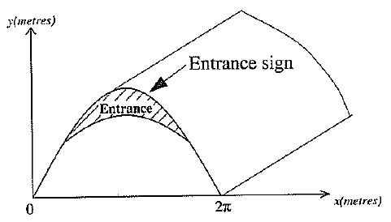9. [2, 4 marks]

At the new Mindarie Funworld Theme Park there

is a boat ride inside a tunnel. The entrance to the tunnel

is shown in the diagram opposite. The shape of the tunnel

itself is found from the rule y =  whilst the lower

edge of the sign is .

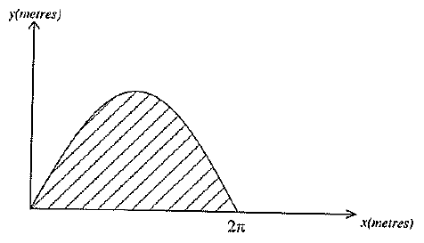

1. Find the exact cross-sectional area of the whole tunnel

entrance as shown in the second diagram.

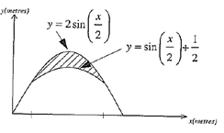

1. Accurate to 2 decimal places, find the cross sectional

area of the entrance sign as shown in the second diagram.

Sufficient working must be shown to receive full marks.

10. [3, 1, 1, 2 marks]

Given that a discrete random variable is binomially distributed such that X $∼$ bin(n, 0.8), and has a standard deviation of 2, determine

1. the expected value E[X]

Use your value of n to determine, correct to 4 decimal places,

1. P(X = 20)
2. P(X $≤$ 15)
3. P (X > 18 / X < 22)

11. [2 marks]

Assume a student does a 20-question multiple choice test. Each question has 5 possible answers, only one of which is correct. In order to pass, she must achieve at least 12 correct answers.

She knows the answers to the first 5 questions, but guesses the rest. What is the probability she will pass the test?